LOST DOG
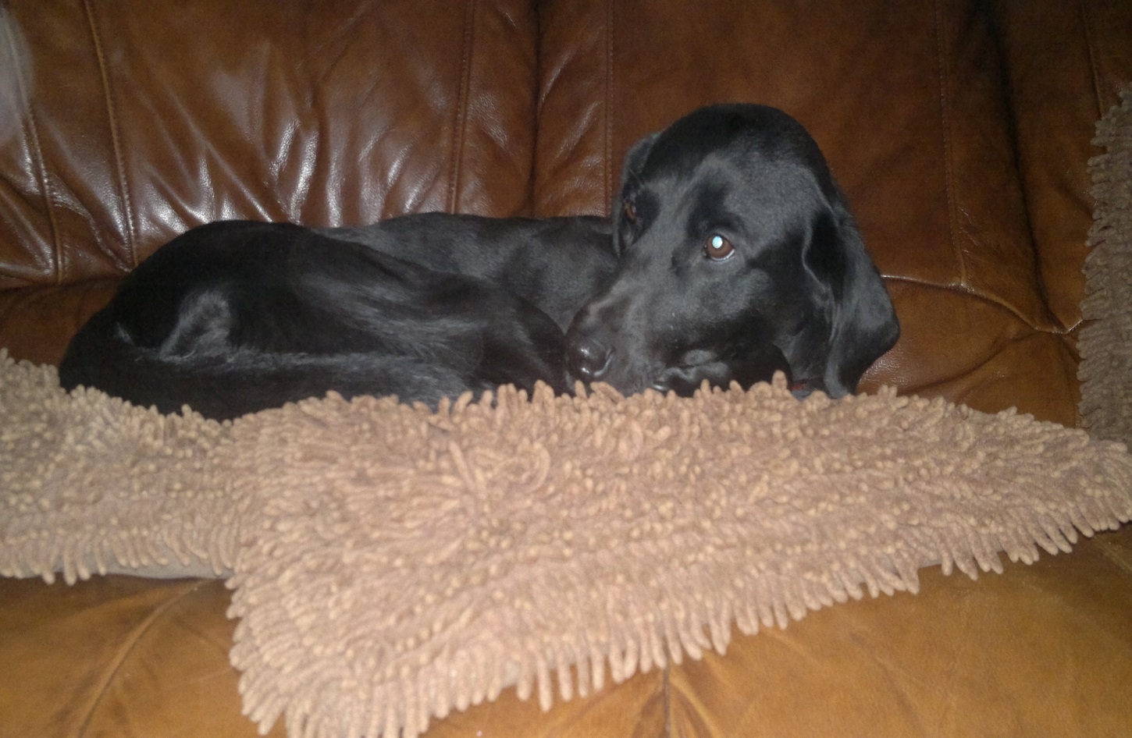Reward If Found
Female Black Labrador
7 Years Old
Answers to the name of Molly
Went missing 7.11.13
PLEASE CONTACT
Mark: 07594 894035 Laura: 07789 357808

