Cheadle & District Animal Welfare Society (C.A.W.)
Sponsored Dog Walk – a gentle walk in Dimmingsdale
Sunday 22nd May 2016, 10.30am
Please help to raise funds so by joining us on a sponsored walk in Dimmingsdale. Starting from the Ramblers Retreat, Red Rd, Alton, Staffs, ST10 4BU. Ramblers Retreat car park http://www.ramblersretreat.co.uk
It may be that you often walk around there anyway but please use this event as an opportunity to raise funds for us by getting your dog walk sponsored!
- There will be a standard £5 entry fee per dog.
- If you not able to arrange sponsorship for your own dog still feel free to join us - maybe you will consider sponsoring the C.A.W. dogs that will be walking?
- Sponsorship forms can be downloaded from the website, obtained from E + E Furniture Stores, High Street, Cheadle, Lime Trees Veterinary Clinic, Tean Road, Cheadle or by contacting us on 07531 232 542
- You can sponsor the C.A.W dogs that will be walking at the above locations too or by contacting us. Pay Pal or Just Giving can also be used- please identify your donation by adding ‘sponsored walk’ as a reference.
For anyone that doesn’t know Dimmingsdale, it is a most delightful area to walk around. There are walks around the ponds and just above them woodland paths.
For our Sponsored walk we are starting from the Ramblers Retreat and suggesting the walk around the ponds and back which is a nice gentle walk of about 1.8 miles. It should take around 40/45 minutes. All dogs should be kept on a lead throughout the sponsored walk. If you use a muzzle for your dog please ensure it is a breathable one.
The official Cheadle & District Animal Welfare Society ‘Walk entry desk’ will be situated on the green outside the Ramblers Retreat main entrance.
- We ask walkers to report to the Start/Entry desk before or mid way into your walk between 10.30am and 11.00am where you can hand in your walk entry fee plus any completed sponsorship forms with sponsorship money (if ready to hand in at this stage), maybe sponsor the C.A.W. dogs that are walking and receive any information about the walking route and receive a badge.
- Groups of walkers will set off around the ponds via staggered starts after 10.30am to avoid everyone walking at the same time and to give other people wanting to enjoy Dimmingsdale the chance to walk also!
- On your return our members will be found near to the ‘Start/Entry desk and also in the gardens of the Ramblers Retreat after 11.30 for you to find and talk to until 1.30pm.
Well behaved dogs are most welcome in the gardens, the summer houses or heated ‘Potting Shed’ at the Ramblers Retreat. Fresh water and drinking bowls are provided in the gardens. Own food and drink cannot be consumed in the grounds. The Ramblers Retreat food is to be recommended anyway! Toilets are situated at the Ramblers Retreat for people who eat food or have a drink there. Public Toilets are also situated at the Picnic Ground in Oakamoor.

The Walk:
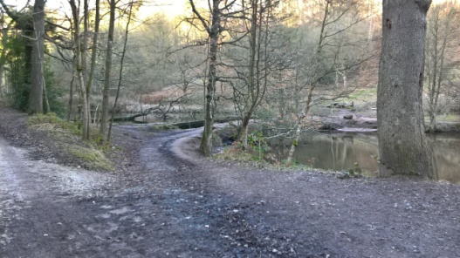
Walk up the path from the Ramblers Retreat main side Garden and keep the two houses, ponds and streams on your right. Carry on just over half a mile until you reach another pond and where there are options to follow different paths and tracks. ** Follow the path in between the 2 ponds and follow it as it curves back along the pond you walked up by, which is now on your right. You will soon come to a section in the path where you will look down and see a wooden bridge on your right across the stream with steps on the opposite bank side. Cross over and go up the steps to turn left to join the path you originally walked up. (You will have seen those as you walked up also) Now retrace your route back to the Ramblers Retreat. The ponds and streams are now on your left hand side.
**Anyone wanting to lengthen their walk can do so by walking up the steps at the top pond near to the Youth Hostel and catching up with part of The Staffordshire Way path in the woodland to return back down to the Ramblers Retreat.
** You can also extend your walk by continuing up the path on the right hand side of the top pond in the direction of Greendale and then cross over the stream a little higher up to return back to rejoin the main walk route back along the ponds to the Ramblers Retreat.
The paths vary from hard-core surfaced tracks to muddy paths, therefore sensible footwear is recommended. Dimmingsdale is a special place and all visitors are asked to follow the Forest Code to ensure it is protected • Leave no litter; • Protect trees, plants and wildlife; Keep dogs under control & clean up after them; Leave things as you find them, take nothing away; • Guard against risk of fire; avoid damaging fences, hedges, walls or buildings.

……………………………………………………………………………………

