WE REALLY DESERVE WONDERFUL HOMES-CAN YOU PLEASE HELP US?
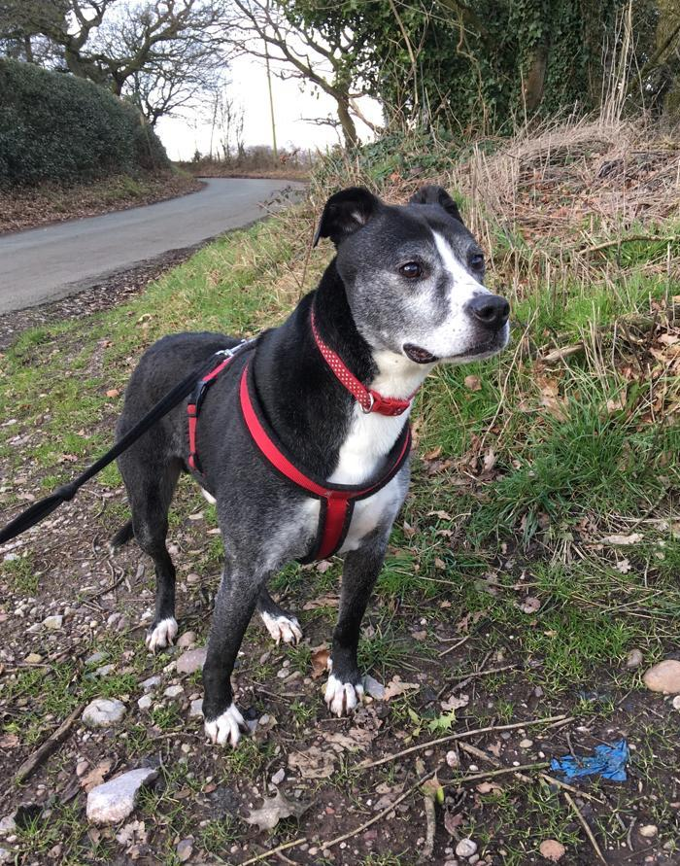 | 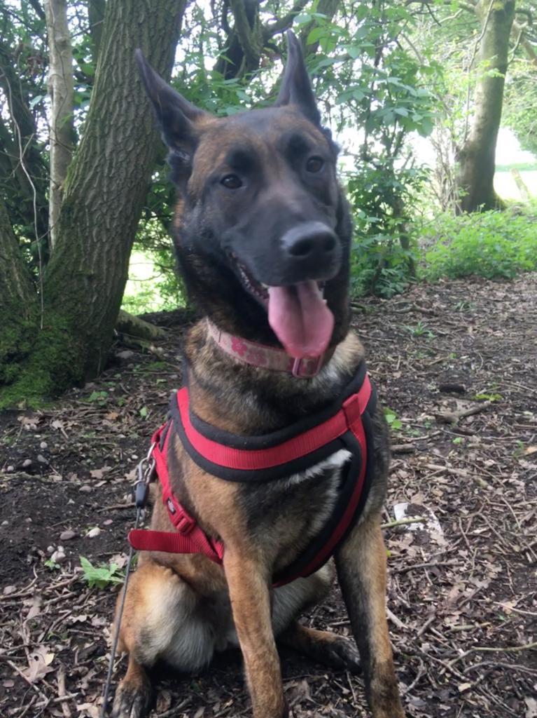 | 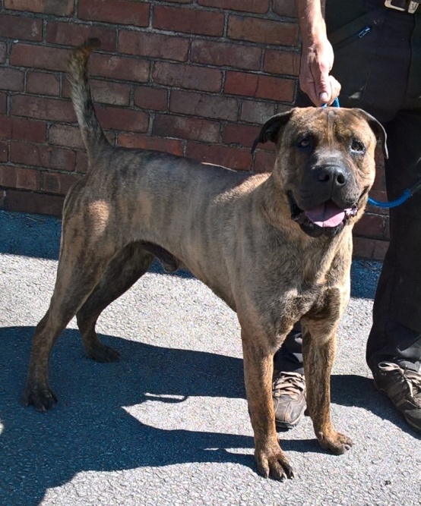
Roger | Roxie | Mikey
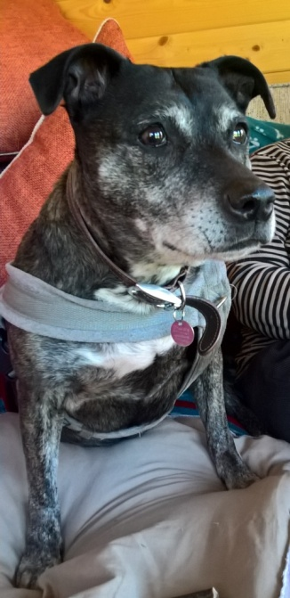 | 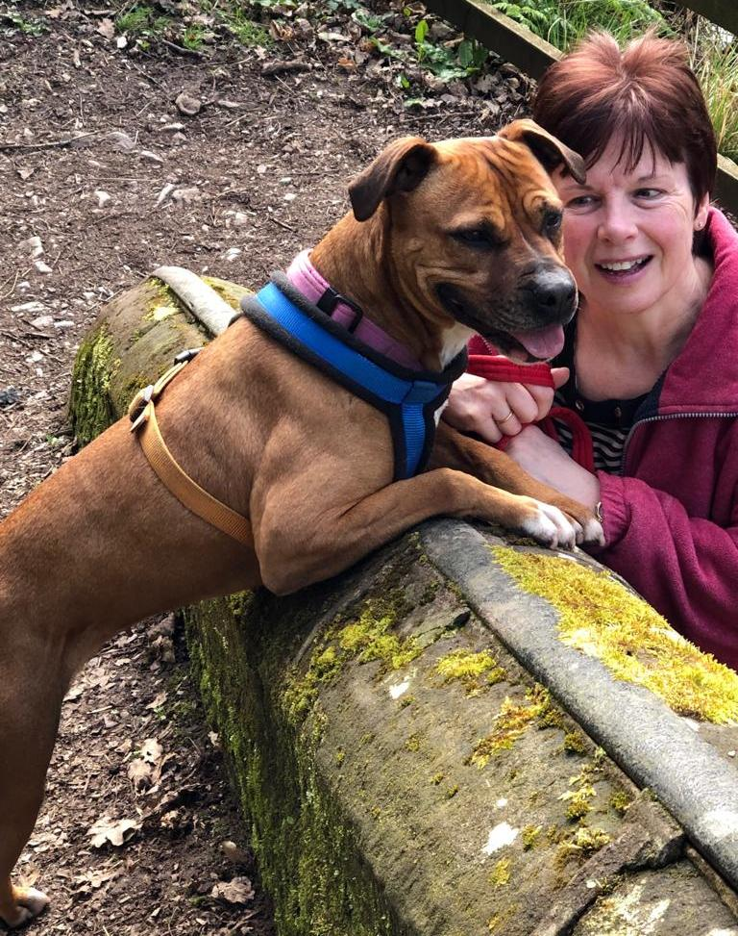 | 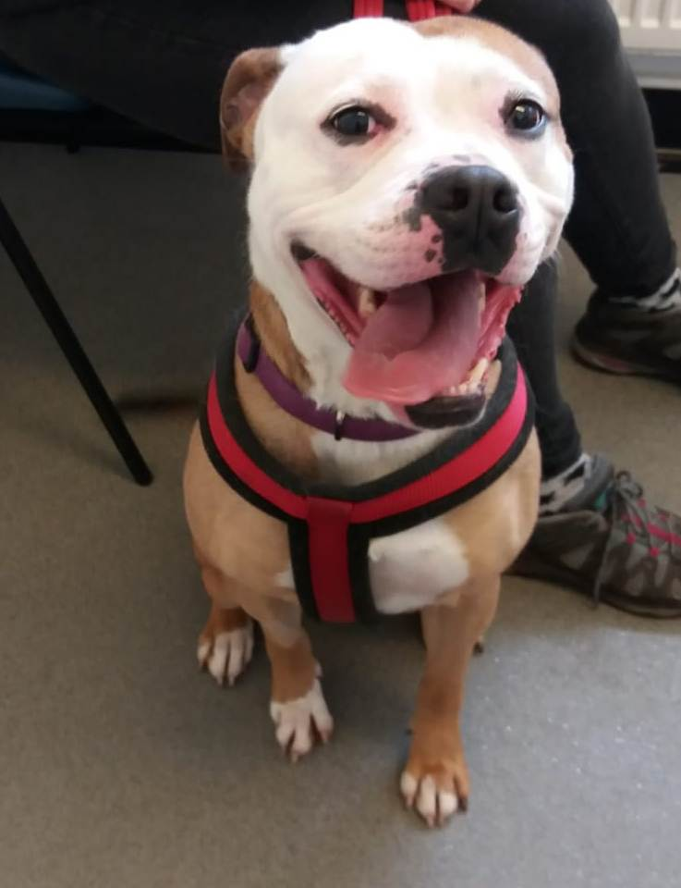
Mabel | Paige | Roxy
 | 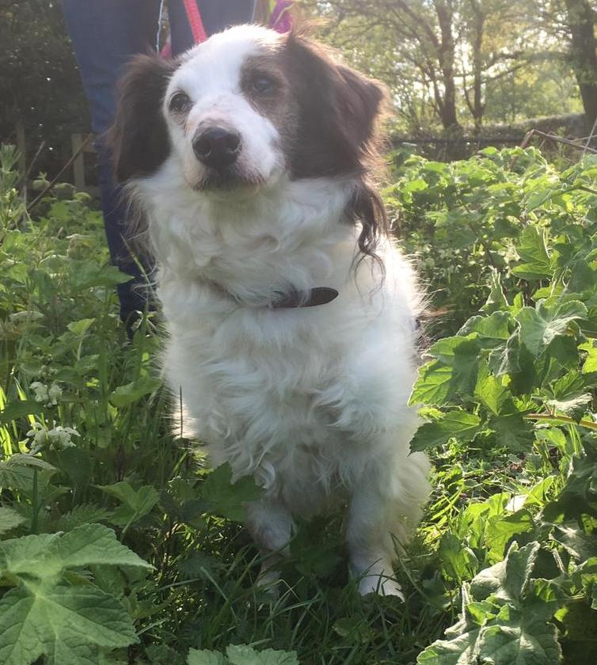 | 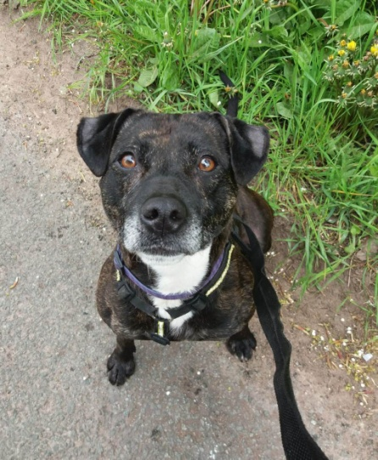
Bruce | Max | Cherry
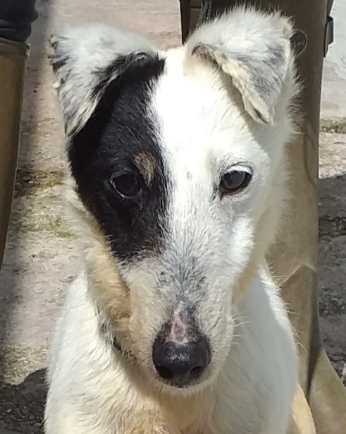 | 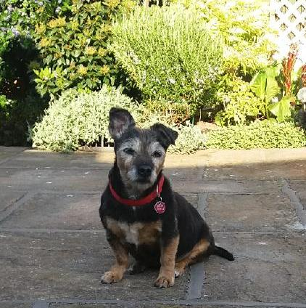 | 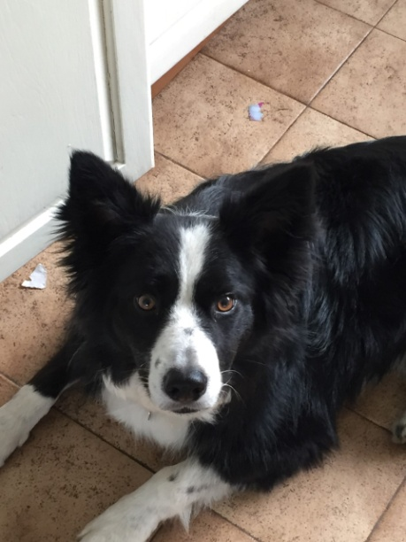
Fizz | Ginny | Rigs
Our details are on www.cheadleanimalwelfare.org.uk
Please Tel: 07531 232 542
or email cheadleanimalwelfare@ hotmail.org.uk
If you can help us

Adopt or Foster us, we really don’t mind!

